Dear [[PARENT NAME]],
[[INTRO]]
As part of the most recent update to our school FrogProgress system, it is now possible for you to view your child’s progress information online.
[[HOW TO ACCESS]]
To use the My Child application to see your child’s progress, please follow the steps below:
1/ Access our FrogProgress platform here: [[SCHOOL URL]]
2/ Enter your username and password. [[Note to school – you may want to provide these with this letter if it is the first time the parents will be logging in]].
3/ Click the Quick Launch icon (the lightning bolt button) in the top bar.
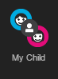
4/ Click the My Child icon to open the application.

[[HOW TO USE]]
The My Child application will show you any progress information logged for your child by their teachers.
It is possible to switch between children using the drop down in the top left of the application. Subjects can be changed using the drop down in the top right of the application.
If you wish to see data from a different term, please use the drop down menu in the centre of the screen.
If any evidence has been uploaded for your child, you can find it by clicking on the name of any of the objectives within the screen.
[[Note to school – you may want to include a brief description of your statuses with this letter and you may wish to update the screenshot below to show your own system]]

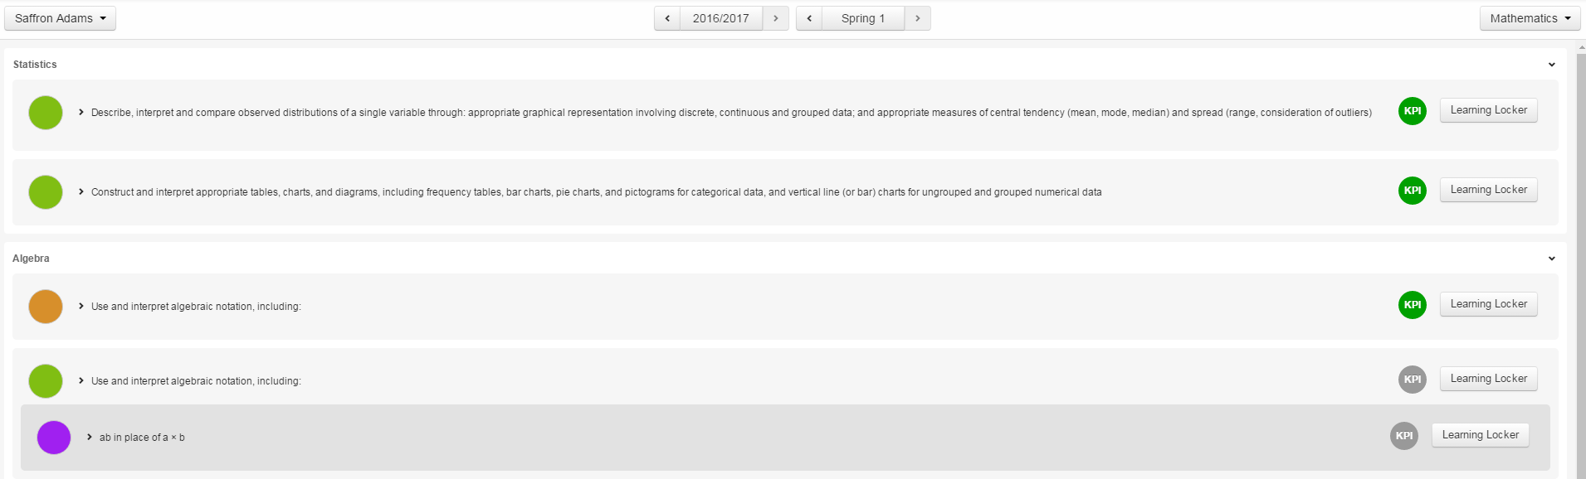
An example of the My Child application. Please note that your school may use different colours than shown.
[[GENERAL TECH INFORMATION]]
For the best experience when using FrogProgress we recommend using a modern browser such as Chrome, Safari, Firefox or IE 11. FrogProgress can be accessed on both desktop computers and mobile devices, but we would not recommend using the system on mobile phones as the screen is generally too small to use the application conveniently.
If you have any questions or problems using the system, please contact [[CONTACT DETAILS]].
[[SIGN OFF]]

Letter instructions for the school
Please ensure that all guideline areas in red have been removed or updated with your school details.
Please ensure that any additional information has been added.
The letter can then be added onto your school headed paper for distribution to your parents.
You may wish to include the following information depending on how much information has already been communicated to parents:
- The usernames/passwords of the parents if they need new ones/reminding.
- A short overview of your assessment statuses.
- A guide to when the data may be updated.
- Why the school has chosen to use FrogProgress/the assessment system.
- A brief explanation of the curriculum.

